**Learn and get to know your calculator!!**

Know the difference between the MINUS button and the NEGATIVE button.

Know how to SQUARE a number and SQUARE ROOT a number.

What is the **2nd** button? All the buttons on your calculator have double duty. They have more than one function. The 2nd button is used to run the function shown above each button.

**Know how to convert your answers into fraction form:**

use the **MATH** button

hit 1 for **1:FRAC** which means fraction

**ENTER**

When you are suing a graphing calculator, it is very similar to a mini-computer. You should type your problems just like they appear on paper, in homework, or in class.

**Don’t forget some simple rules!**

Zero divided by any number = zero. This mean zero is on top of a fraction.

Any number divided by zero = undefined. This means zero is on the bottom a fraction.

Any number raised to the power of zero = 1

A negative number times a negative number = a positive number

A negative number times a positive number = a negative number

**EXAMPLES:** perform the indicated operation using your calculator and give all digits in your calculator

2.8 x (3.2 – 1.1) =

3.492 = 1.486 = 1200 =

**EXAMPLE:**

The bar graph in the figure below show the US sales of motor scooters which have gained popularity. The graph compares sales in thousands. Answer the following questions:

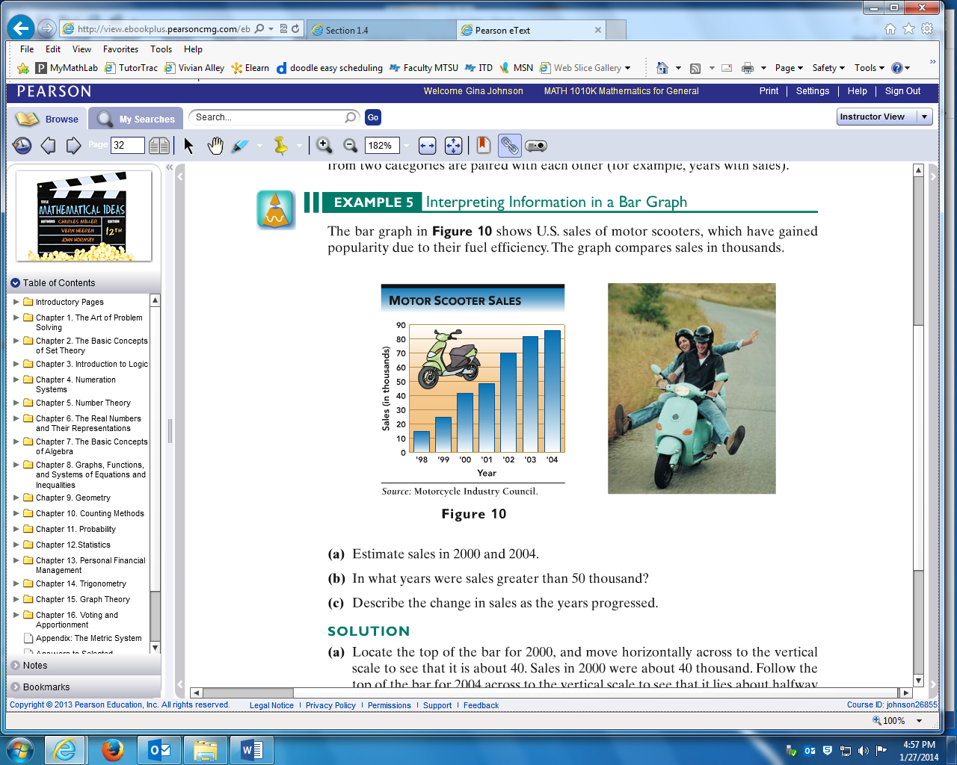

1. Estimate sales in 2000 and 2004.

2. In what years were sales greater than 50 thousand?

3. Describe the change in sales as the years progressed?

**EXAMPLE:**

The circle graph below shows the approximate percent of immigration admitted into the US during the 1900s. Answer the following questions:

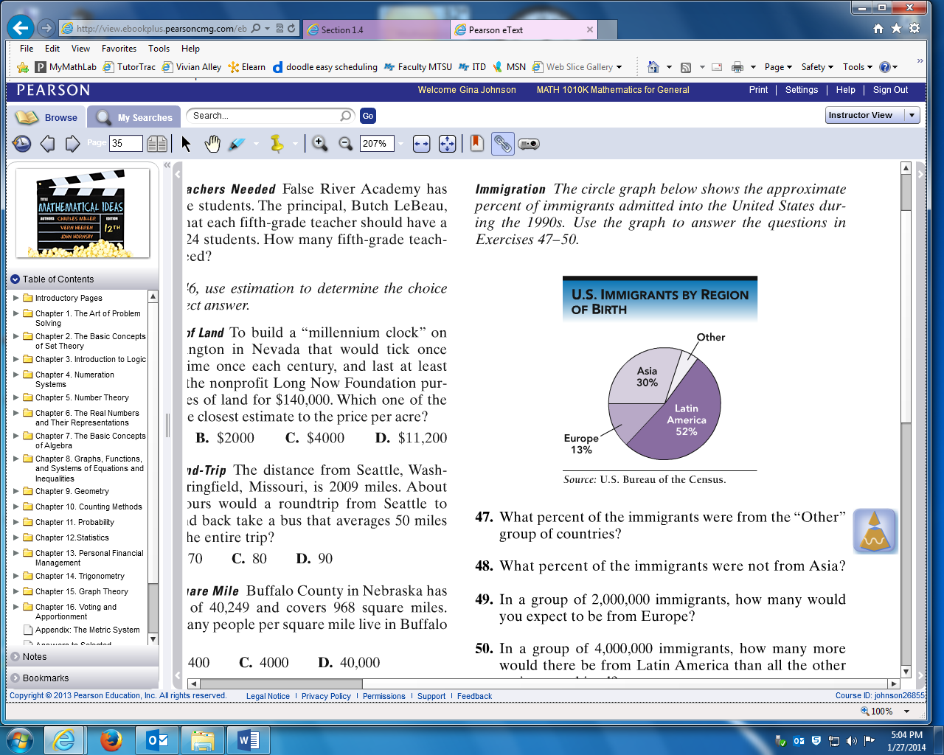1. What percent of immigrants were

from the “other” countries?

2. What percent of immigrants were not from Asia?

3. If the circle represents 2,000,000 immigrants,

then how many would be from Europe?